TOPIC: THE IMPACT OF DATA ANALYTICS APPLICATION ON BUY NOW PAY LATER BUSINESS IN NIGERIA

Table of Contents

CHAPTER ONE: INTRODUCTION 4

1.1: Research Background 4

1.1.1: Background on Buy Now Pay Later in Nigeria 5

1.2: Problem Statement 7

1.3: Research Objectives 8

1.4: Research Questions 8

1.5: Significance of the study 8

1.6: Scope of the Research 9

1.7: Definition of terms 9

1.8: Chapter Summary 10

CHAPTER TWO: LITERATURE REVIEW 11

2.1: Introduction 11

2.2: Theories of Business performance and Management 11

2.2.1: Systems Theory 12

2.2.2: The Principles of Administrative Management 12

2.2.3: Bureaucratic Management Theory 13

2.2.4: Classical Management Theory 13

2.3: Data Analytics 15

2.4: Practices regarding Knowledge Management 16

2.5: Organizational Business Performance 17

2.6: Existing Application of Data Analytics to the Business Performance 18

2.7: Knowledge Management and Business Performance 19

2.8: The situation of the Buy Now Pay Later Strategy in Nigeria 20

2.9: Conceptual Framework 20

2.10: Research Hypotheses 21

2.11: Chapter Summary 21

CHAPTER THREE: RESEARCH METHODOLOGY 23

3.1: Introduction 23

3.2: Research Philosophy and Research Approach 23

3.3: Research Design 24

3.4: Sampling Procedures 24

3.5: Research Instrument 25

3.6: Data Collection 25

3.7: Data Management and Analysis 26

3.8: Ethical Considerations for the Research 27

3.9: Chapter Summary 27

CHAPTER FOUR: DATA ANALYSIS 29

4.1 Introduction 29

4.2 Dataset Description 29

4.2.1 Research Objectives 30

4.3 Analysis 31

4.3.1 System Environment 31

4.3.2 Data Preparation 32

4.3.3 Data Cleaning 33

Figure 2: Above is a figure showing cleaned dataset with no missing values 34

4.3.4 Data Statistics 34

CHAPTER FIVE: RESULTS AND FINDINGS 36

5.1 Research Objective 1 36

Figure 3: Above shows frequency of Later Payment Status of the customer 37

5.2 Research Objective 2 38

5.3 Research Objective 3 40

Figure 6: .The customer purpose goods leading group 41

Figure 7: The above graph shows the Mean of goods sold to the customers against the budget spent on each group of goods. 42

CHAPTER SIX: DISCUSSION 43

6.1 Research Objective 1 43

6.2 Research Objective 2 44

6.3 Research Objective 3 45

6.4 Limitations 46

6.5 Conclusion 46

6.6 Recommendations 47

REFERENCES 49

# CHAPTER ONE: INTRODUCTION

## 1.1: Research Background

Within the past two decades, there has been rapid development and changes being seen in the field of data analytics. This has seen a rise in the interest of researchers and academicians. This is through the conduct of a series of studies across a variety of industries that have been attributing and associating their success and good performance with the use of data analytics techniques. Further, there has been a steady, and notable advancement in the recognition by the officials of the prospective benefits that are associated with data analytics (Ain et al., 2019).

Regarding the consideration for the investments made by both the public and private in data analytics, there has been a continued growth in the amount of revenue generated all over the world. Data analytics can improve and increase the level of efficiency and effectiveness within a business with specific consideration of the high ranks of strategies which have been addressed for the operational potentialities, which will then make a contribution to a change in the performance and growth of the business. (Bag, et al, 2020). Businesses and organizations that tend to have a high performance, have to take into account data analytics as an important differentiator and an important tool for any of their potentiality and continuous growth.

The data analytics are put into use for the provision of insights that drawn and obtained from data regarding the importance of being in competition and also being in the likelihood to be gained or drawn by these institutions. To be specific, data analytics are taken as being a pillar or a paradigm of science by scholars and also some practitioners. It is taken that data analytics will be the next inventive, competitive, and productive phenomenon for knowledge assets (Daradkeh, 2018). Data analytics has been considered to be an important segment that spar growth and also indicate the difference created, mainly by the organizations that do have a high record in their performance.

There is an exploration for the association and the link between how the data analytics are applied and the level of performance in any business, this being even with the prevalence of the great importance and the research interests. The learning of data analytics has continually been incorporated into academic learning. There have been only a few research studies conducted to explore the utilization of data analytics for enabling performance in a business (Dubey et al, 2019). Further, to reveal insights into the existing research gap, there is the need for exploring a link between data analytics and knowledge management practices in business considering the buy now pay later business models in Nigeria.

### 1.1.1: Background on Buy Now Pay Later in Nigeria

There has been a continuity in the urge by some of the Fintech companies in Nigeria by allowing a large proportion of the population to access the model of Buy Now Pay Later. Per some experts, this will see a positive trajectory in one of Africa's biggest economies, which has been fragile ad weak. The availability of this model of business will help in boosting the spending of the consumers, the boost sales and as well as economic activities and growth.

This model is a form of short-term financing that does enable shoppers to make a purchase of their items and claim ownership through payment of a certain proportion of the cist at the moment and later the balance is spread to be paid over a time frame that is agreed upon. This model has its target consumers being the young, millennials mainly between 25-to-40-years of age (Dubey et al, 2019). It requires one to have a verifiable source of a stable income or a salary and a bank verification number.

For businesses, the credit does facilitate transactions, this being mainly among the Micro, Small, and Medium Enterprises that have the desire for procuring large-scale materials or equipment. There has been advocation for these businesses to tap this opportunity that does boost their commercial activities. It is notable that the majority of economies do run on credits and are developed as they increase their consumption, which is of great importance for any economy to realize growth.

In Nigeria, the millennials do account for close to 58% of the total persons that are gainfully employed. Hence, this is evident enough that the model of buy now pay later has a serviceable market. Fintech has been licensed to give and offer loan facilities. They do only rely on the banks that have access to provide people’s accounts and the bank verification numbers for them to collect their money in installments (Ghasemaghaei, 2019). This makes it a loan. The difference that exists is that they do now attach it to a specific item or asset. Among the major FinTech companies that do offer the buy now pay later business model in Nigeria are; Carbon, EasyBuy, and CredPal.

For Carbon, it does enable customers to purchase electronics and gadgets while still paying in small installments at a zero percent interest rate. This was launched in 2020. Nevertheless, before making a purchase, a specific percentage of the total cost is paid upfront. After this, then the customers can pay the remaining balance over six months. EasyBuy was founded in 1996, though started to operate in 2019, being a mobile devise financing platform created for people who want to make purchases for phones and pay in installments. EasyBuy provides a point-of-sale (POS) loan to intending customers who may be willing to buy a mobile phone. The company requires the customer to make a payment of at least 30 percent (Ghasemaghaei, 2019). The remainder of the balance could be paid in three months at an interest rate of 9 percent or within six months at an interest rate of 6 percent. Credal was founded in 2017 and provides revolutionary credit solutions by utilization of easy credit access for businesses and individuals across developing countries. The services offered by the company do allow for a flexible payment option that helps the businesses and individuals to buy anything and later pay for it in installments across merchants that could be online and offline by providing them with instant access to credit at the point of checkout.

## 1.2: Problem Statement

The continued wide and broad usage of data analytics techniques is important and of great importance for any business’s conduct and operations. Within this same aspect and breadth, the bought model now pays later businesses has so hugely made reliance on data analytics. This has seen an influence and an impact on the performance in the manner of operations and the conduct of doing business (Ghasemaghaei, 2019). As such, there exists the need for evaluation of the extent, breadth, and level of engagement of these businesses in the use of data analytics and how it improves their performance.

Hence, this study will be making an exploration and an examination of the existing relationship between data analytics, organizational performance, and knowledge management practices in the business model of buy now pay later within Nigeria. This will be of great importance in providing recommendations to all the stakeholders within this form of business ranging from the customers to the companies that make these sales.

## 1.3: Research Objectives

The research objectives for this study were based on the defined research objectives and the identified research gap. As such, the following were the highlighted research objectives for this study.

1. To determine the effect of using data analytics in buy now pay later on businesses’ performance in Nigeria.
2. To evaluate how the data analytics are used in the buy now pay later businesses to influence the knowledge management practices in Nigeria.
3. To analyze the impact of the buy now pay later business strategy on customer satisfaction and business performance.

## 1.4: Research Questions

The following were the developed research questions as drawn from the research objectives for the study.

1. What is the effect of using data analytics in buy now pay later business models on the businesses’ performance in Nigeria?
2. How is data analytics used in the buy now pay later business model and towards influencing the knowledge management practices in Nigeria?
3. What is the impact of the buy now pay later business model on customers’ satisfaction and business performance in Nigeria?

## 1.5: Significance of the study

The findings that will be drawn from this study will be of great significance to a series of stakeholders encompassed within the business model of buy now pay later and the utilization of data analytics. Among these will be the customers, the business operators, and even the external lenders.

First, the customers will draw insights on if this platform of buying a product at the moment and paying later is a worthy venture. As such, they will be better informed in their next instance that they may want to purchase this model. Secondly, the business operators will be the key beneficiaries of the findings and the recommendations of this study. This is since they will directly have a glimpse of if the utilization of data analytics indeed influences their business performance and the manner of operation of a business. These business operators will be in a better position to understand if there are any gaps they could potentially improve or as well if this model is indeed drawing more customers to their stores. Finally, the lenders will have the opportunity to understand if their offer for financial facilitation to the customers does yield any significant importance to the operation of businesses and to the efficiency of doing business.

## 1.6: Scope of the Research

The study will have its bases being on the strategy of buy now pay later within Nigeria. The main focus will be on the business operators that have made adoption of this model for doing business. The research will utilize questionnaires to gather data from the prospective respondents. All the respondents will be persons aged above 18 years of age and will only take part in the study voluntarily. The same will be engaged within organizations and companies that have adopted the buy now pay later business model for their operations. All the participants will be informed of the importance of the study, and any of them will be free to withdraw their participation from the research at any stage even after having started to complete the questionnaires.

## 1.7: Definition of terms

The following terms which were mainly utilized across this study were defined below.

Buy Now Pay Later – this is a type of short-term form of financing which allows the consumers to make purchases and later make the payments at later dates, mainly with no interest attached to the same.

Business Performance – this is the ability of a company or a department within the company to achieve its objectives and its expected results.

Data Analytics – this is the science and the skills to analyze raw data to make conclusions about that information.

Knowledge Management – this is the efficiency in the handling of information and the resources that are within an organization or a company.

## 1.8: Chapter Summary

This chapter being the first in this study was an extensive coverage for the introduction in the essence of the aspects of the research that would be covered. The chapter made an extensive exploration into the already existing background of the phenomena being evaluated. These are in the aspects of the data analytics and the presentation of the business model of buy now pay later as it is presently in Nigeria. Further, the chapter presented the specific objectives and questions that were to be analyzed and evaluated in the current study. Thus, the chapter formed important precedence to the chapters that followed as to the extensive coverage of these aspects.

# CHAPTER TWO: LITERATURE REVIEW

## 2.1: Introduction

This being the second chapter for this study, presented the kye and important studies that had been conducted before the current study. These were presented within the breadth of discussion of the various theirs that regard and related to the phenomena under research. Further, an exploration for the presentation of the findings in the studies conducted previously in the aspect of the features being investigated was presented in this chapter. The findings were of great importance, as they would enable the researcher to make a comparison of the same in the future chapters while drawing study conclusions and recommendations. The theories would as well make a comprehensive representation of the already existing information on these phenomena.

## 2.2: Theories of Business performance and Management

There do exist several theories of business being in either management and that lead to influencing the performance of the same. Among these theories are; the systems theory, the principles of administrative management, bureaucratic management, and classical management. For each, their discussion was made in this section, and its relevance to the current study was well-drawn.

### 2.2.1: Systems Theory

Through the creation of this theory, it had no subject to do with business management but was focused and aimed at the exploration of biology. This was since a biologist named Ludwig Von Bertalanffy who lived between 1901 and 1972 founded the general systems theory. This was towards an attempt to counter reductionism and revive the unity of science. The theory has its premises on the fact that a system is composed of interacting elements that tend to be affected by its surroundings (Dahlgaard-Park, et al, 2018). Due to this form of interaction, then the system as a whole tends to have the potential of evolving as well as regulating itself.

In the business application, the experts have summed up this general systems theory as just systems theory. It is more of a perspective than a complete practice. The theory tends to encourage a realization that a business is a system and is governed and directed by laws that could be considered to be similar to the laws that affect every other biological organization.

The exploration of this theory saw the introduction of some of the concepts such as entropy, which is the tendency for a system to run down and collapse, this being an aspect that all businesses should endeavor to avoid. Synergy is also another concept developed through this theory and makes reference to working together, it can produce something bigger than those similar parts could produce if they were on their own.

### 2.2.2: The Principles of Administrative Management

The theory on the principles of administrative management was developed by Miner and Engineer Henri Fayol, being an approach top-down to examining a business. The engineer envisioned himself as a manager and contemplated the various situations that they were likely to encounter while dealing with their respective teams. He made several conclusions that his managers had a series of six responsibilities whenever it was to manage their employees (Alqatan, Chbib, & Hussainey, 2021). Among these responsibilities included; organization, command, control, coordination, planning, and forecasting.

Among these responsibilities have been in the mind of Fayol, he developed fourteen principles of administration that do influence how managers lead their teams. These principles have a range from having the importance of maintaining a facility that is clean to the valuation of an initiative and the teamwork too, being the foundations for the majority of the current successful businesses.

### 2.2.3: Bureaucratic Management Theory

Through the creation of this theory, Max Weber took a more sociological approach and attempts its creation. His ideas were founded on the importance of the structure of a business in a hierarchical manner that had clear rules and roles too. According to this founder, he made a relation of the ideal business structure is based on a clear division of labor, clear distinction of personal assets and those that belong to the business, the hierarchy in the order of command, proper keeping of records, the promotion of employees based on their performance merit, and further having the consistent form of regulations (Maylor, et al, 2018). This has been commonly perceived as being an impersonal style that has the potential of getting overwhelmed by some of the rules or formalities and procedures. It however can be of great use and importance to the businesses that are recent startups and need standards, procedures, and even structures.

### 2.2.4: Classical Management Theory

The classical management theory is predicated on the foundations of the idea that the employees do have only the physical needs. On the fact that the employees can satisfy these needs with money, then the classical management theory does have its focuses on the economics of organizing the workers. As such, then the Classical Management Theory does ignore the personal and social needs that tend to influence the levels of job satisfaction of the employees. Thus, the Classical Management theory does make an advocation a series of principles (Alqatan, Chbib, & Hussainey, 2021). This theory does advocate for profit maximization, labor specialization, and priority to the bottom line. Additionally, the theory has an emphasis on centralized leadership, the streamlining of operations, and having more focus on productivity. This is notwithstanding the emphasis put on the individual or small groups for decision-making.

If the principles are fixed and adopted accordingly, they do create an ideal place of work based on a hierarchy structure, the specialization of the employees, and any rewards that may be in form of finances.

The management of the business is held by a few who have the obligation for exercising exclusive control over any decisions and the direction taken by the company. Among these select few, the middle managers take the role of governing and managing the daily activities of their employees who are at the bottom of the pecking order.

Across all these, they happen within the conceptual idea that the employees have to work extra harder and create more productivity for the instance that they must get bigger rewards in increments to their salaries and wages. However, this might not be so ideal for the current business environment, this was much in order and working for a long period at the beginning of the 20th century. Despite the that this system is not currently in an application, there exist some key ideas that the managers in the current century could make use of (Daradkeh, 2018). Among these include a clear managerial structure, a clear division of labor, and a clear definition of the roles of the employees in an organization. The three have the capacity for the alteration to and improvement of how the employees and the businesses tend to work in the current times.

## 2.3: Data Analytics

The data analytics has been defined to being a collection of the enormous amounts of data and technology that have the possibility of having been obtained across several sources and are utilized to make decisions that gain and do edge in business against those who may be their competitors and thus do enhance the performance of certain businesses. There exists a series of observational data that have been utilized in the endeavors of making decisions, the data analytics which tends to be broad to the extent of big data, do tend to be real-time information, media data in a non-traditional form, that is governed by the modern form of technology, social media platforms, and even huge volumes of data (Grover et al., 2018).

There has existed a consideration for the various and the volume in big data, and there exists no certain form on the same. Broad researches have made highlighting of the vital roles of veracity and velocity. As such, there is clarity on the importance of the skills of data analytics in the components of analysis of data. These consist of procedures that involve procedures of accumulating, consolidating, and scrutinizing the data towards making exploitation of the extremely huge datasets from the non-conforming available resources to make and draw decisions on any trends that exist on the information for improving and the purposes of decision making, with a specialty being at the levels of management.

Further, data analytics are defined and perceived as being the way through which there is a determination and achievement of substantial measures from data to even the making of a backup in the processes to make a decision. Data Analytics does entail several tools that are set for inspection of data that is obtained and drawn from both internal and external sources to make discoveries for any significant and meaningful trends (Hadi et al., 2018). Hence, the data analytics do create value for which several enterprises do make the adoption of the same for the reason of getting and drawing assistance in their processes of making decisions. Therefore, data analytics do require competency for it to be useful in making findings into the implications and also in the development of any institutions.

Finings have also been gathered regarding the significance of data analytics utilization in the organization. It is extensively found and informed that the data analytics used in any business have been of great help in the making of more informed decisions and also the process is better. The researchers have cited those analytics help makes a more informed decision. Further, there are findings associating data analytics with greater revenues in a business (Hallikainen et al., 2020). The companies that tend to adopt and embrace the use of data and analytics initiatives have the potential of experiencing meaningful financial returns. A research study that was conducted by McKinsey indicated and had results implying that the organizations that have made investments in the big data do have and yield at least a 6% increase in their return as profits and have the potentiality of even leading to 9% for over 5 years in time (Kamble, & Gunasekaran, 2020).

The use of data analytics was further associated with an improvement in the operational efficiency of a business. This is beyond the utilization of data analytics in gaining financial value for a business (Khanra et al., 2020). There were findings implying that a majority of firms and businesses do currently make use of the predictive analysis to create anticipation maintenance and their operational issues before they become larger problems.

## 2.4: Practices regarding Knowledge Management

There is the second aspect which is knowledge management. In this regard and its breadth, their practices do make facilitation the systematics procedures for the creation of information, the steps into the acquisition, and even to further make conversions and the applications for the same. They do involve several steps for the process of how the acquisition is done, the manner of storage, the steps for the distribution of the same, and further the application of the knowledge (Komarova et al., 2019). The process of knowledge creation is perceived and seen to be an important segment in knowledge management theories. These practices do include and involve steps for the conversion of tacit and explicit information.

The knowledge is considered and perceived to be powerful and does help in the making of solutions for existing problems that tend to be likely to be existent within a business organization. The process is also a stage in the process that tends to help in sharing of resources for the knowledge and the improvement of the good and appropriate organizational performance. This does spar the growth and also an advantage that is competitive (Lim, et al, 2018). Business organizations do tend to have great concerns in the regard to the process of creating and managing the knowledge for them to ensure they have sustainable business performance and productivity.

There have been existing empirical studies that have been a subject of exploring the relationship between knowledge management and business performance. A study conducted within this breadth affirmed that orientation of knowledge management has a positive role in the promotion of organizational performance in China (Petrillo et al., 2019). A second study further made the revelation that the knowledge management does have a positive influence on the performance of manufacturing firms, as well, the explorations indicating that for the organizations to be in the position of achieving and maintaining a high level of performance, they ought to give responsibility to ensure they develop and maintain mechanisms that are efficient for the creation, transfer, and integration of knowledge.

## 2.5: Organizational Business Performance

Organizational business performance is referred to the ability and the capacity of a business in achieving its objectives and meeting its set objectives for the existing stakeholders to remain relevant in the market. Additionally, the organizational business performance could be defined to being the process that consists of the analysis and the assessment of the outcomes in an organization that relate to the objectives and the aims of the company (Petrillo et al., 2019). They do include the comparison for the outcomes being both the actual and those that are planned strategically for the business.

The organizational performance does include and extends to the level of productivity and the obtained outcomes for set objectives and timelines. There continue to be emphasis being made on the increase in the levels of performance to being reliant on the capability of a business to have the enabling capacity for them to cope with the existing innovations, their protections, and also the utilization of knowledge assets that are intangible in a way that can result to some forms of advantages to the operations of the same business (Popovic et al., 2018).

Further, the business performance is also perceived and seen to be the process through which the resources in an institution are well utilized, thus involving the activities that the management research towards the proper usage of the data analytics in business do take at the different levels in a business for examination of the extent to which a business organization has attained their aims and persuasions (Queiroz, & Telles, 2018).

## 2.6: Existing Application of Data Analytics to the Business Performance

There have been an existent large number of different software for data analytics having been made available to the users for purposes of utilization in data analytics and to enable organizational performance and to as well make properly informed decisions that further have the effect to influence success within a business. A business is subject to getting information to be utilized in the making of decisions that are driven analytically into huge quantities for application of big data analytics, and further have the potentiality of helping an organization to improve the performance and also attributes to better prices for these organizations in making of decisions that are well informed by the data (Raut et al., 2019).

An example of the utilization of data analytics and its performance is the Amazon company. The organization does obtain two-fifths of the sales drawn from referrals and recommendations that come from persons or customers based on the performance and use of data analytics Ritter, & Pedersen, 2020). This is seen to being a perspective that has an outcome of creating the value for the businesses and further being an effective implementation for this data analytics that tends to inclusivity of the essential level of expertise through its process for guiding in the big data, the process of extracting the meaningfulness of this data and to the development of information from the data.

An approximate proportion of 90% has invested in data analytics compared to the proportion of less than 80% that had made this investment in the previous years (Singh & El-Kassar, 2019). There have been considerations being put in place regarding the data analytics as being taken to be a measure for the level of performance regarding the management of a business and the level of management for their assets that exist within their organization and also for the process of monitoring their business.

## 2.7: Knowledge Management and Business Performance

The correct utilization of the natural resources and any material that is relevant provides to be having a role in the service for their complete role towards improving the performance. The other significant feature is clear knowledge management practices. Knowledge does pose as being an asset that has been linked to the business levels of performance. Knowledge management is seen as being the process of reflection on the strategies for which there is the acquisition and creation of knowledge (Tseng et al., 2019). The process of sharing and distribution of the insights is seen to be for the preserved and confidential information that tends to be within the firm and for the application of the attributes and the insights that are drawn from the same. Businesses have been using these knowledge management practices and making to achieve the knowledge-driven systems to make improvements in the levels of competition and the values too.

Great relevance does lie in the understating the form and the nature of knowledge, the tactic knowledge, and the level of explicit knowledge being the basis for the knowledge. There is likely to be a troublesome phenomenon while trying to achieve the tactic knowledge, especially in exchange with another person (Zhou et al., 2018). Thus, it is hence evaluated to being within the form of competence, the levels of their expertise, and even the various ideas on which people are likely to hold about themselves and even their mentality.

## 2.8: The situation of the Buy Now Pay Later Strategy in Nigeria

the model of Buy now Pay later as a form of business operation in Nigeria has been common and evident concretely and magnificently. This has been mainly evident among the businesses that are operating the electronics shops. The buy now pays later business model has been extended in the sense that the customers are allowed to have access to the products they desire on different terms (Zaim et al., 2019). The customers are required to pay either a certain proportion of the total cost before starting to use the products or are fully allowed to have access to the items and later make the payments in installments. Some of the businesses have allowed the customers to have the access to these items with no interest charges on the overall costs.

## 2.9: Conceptual Framework

The following was the plot for the conceptual model of this study.

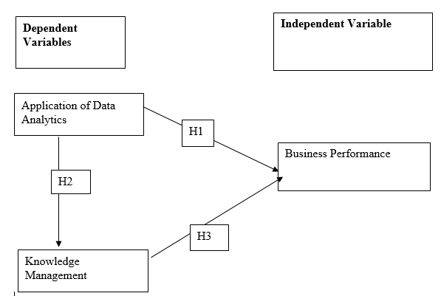

## 2.10: Research Hypotheses

The following were the developed research hypotheses

H1: There exists a positive relationship between the application of data analytics and the but now and pay later businesses in Nigeria.

H2: There exists a positive relationship between data analytics and knowledge management practices.

H3: There exists a positive relationship between the knowledge management practices and the performance of the buy now pay later businesses in Nigeria.

## 2.11: Chapter Summary

This having been the second chapter in the study, played a significant role in the presentation of the literature review of the entire research within the scope of the objectives and the aims of this evaluation. The chapter formed an important foundation for the subsequent chapters and the entire research study.

# CHAPTER THREE: RESEARCH METHODOLOGY

## 3.1: Introduction

The third chapter which was the research methodology was of great importance in this study, this being towards the representation of the various techniques and the procedures followed for the study. Thus, this chapter made a presentation and a discussion of the research philosophy, approach, and the research design. Further, the research sampling procedures and techniques adopted for the study were discussed as well. The research instrument utilized for this study with the data collection procedures adopted were discussed and presented in this section. Additionally, the data management and analysis techniques with the ethical considerations for the study were discussed too.

## 3.2: Research Philosophy and Research Approach

Research philosophy is any belief that is in existence about the manner and any of the techniques by which certain given data for a phenomenon under investigation is supposed to be gathered and evaluated being in form of analysis, and later the findings be used to make conclusions and recommendations. There are a series of different research philosophies that are possibly applicable ins a research study (Kadam, & Joshi, 2019). The specific research philosophy is determined by among other factors the nature of the data that is needed.

For this study, a positivism research philosophy was adopted to be utilized. This was based on the fact that this research philosophy does focus on seeking reality and the stability which can be observed. Mainly, this is seen from an objective point while having no interference with the phenomenon that is under study and investigation. This philosophy is guided by the isolation of the factor or the phenomenon being studied while the observation is being made.

The research approach is defined as the plan or the procedures that do include the studies of the broad assumptions to the detailed methods for data collection, its analysis, and the interpretation. It is in essence mainly based on the nature of the developed research problem that is to be a subject. Mainly, the research approaches are either qualitative or quantitative. For this study, a quantitative research approach was adopted. As such, primary data would be utilized to evaluate the specific research objectives. Further, this research approach would utilize numerical data gathered through the distribution of research instruments.

## 3.3: Research Design

The research design is defined as the procedures that are utilized for the process of gathering data, the utilization of the same as well as its management regarding the aims of the research study (Kostere, & Kostere, 2021). This does usually regard and has to be systematic with the formulated research aims and objectives for the study that is to be investigated and established in the context of the gathered data.

In this study, the researcher adopted the descriptive research design to collect data, analyze the same, and present both the results and the conclusions. This was found to be suitable as it allowed the researcher to make a presentation of the quantitative data in tabulations and graphical charts. As such, making it easy the interpretation and the relation to the specific research objectives and the aims of the current study.

## 3.4: Sampling Procedures

The sampling procedures are either probabilistic or non-probabilistic. The probabilistic strategy does allow for the population to have equal chances of being selected to be engaged as a sample for a specific study which is not the case with the non-probabilistic sampling strategies. The sampling strategy must as well conform to the requirements of the study and be in line with the study objectives and aims. This is as well as having the sample being a representative of the population upon which a specific study is being conducted (Goodman, Robert, & Johnson, 2020).

For the evaluation of this study, a sample of 100 respondents was selected to be engaged in the study. This was drawn from the person working in the businesses that have adopted the buy now pay later model. The respondents were selected by simple random sampling. Thus, this enabled each of the persons working within these companies to have an equal chance of being enrolled in the sample to be engaged. Their participation was fully voluntary and none of them was compelled or coerced into taking part in the study. Their consent was sought prior being issues with the research instruments.

## 3.5: Research Instrument

The research instrument is defined to being a tool that is utilized by a researcher for engagement and the purpose of communication with their respective respondents. The research instruments do vary and are extensive always based on the nature of research that is being conducted and the type of data that is intended to be gathered (Diaz-Kope, et al, 2019). Among these research, instruments include; questionnaires, interview guides, and recorded conversations over phone calls.

For the exploration of the impact of data analytics applications on buy now pay later businesses in Nigeria, a research questionnaire was adopted for utilization in the study. The research questionnaire was found to be the most appropriate as it would enable coverage of all the variables that were deemed to be of importance in the current study. The questionnaire measured a series of features beginning with the demographic profiles of the respondents, and later the specific variables.

For the dependent and the independent variables, the questionnaire would measure each of them in a series of statements that were measured on a five-point Likert Scale for the levels of agreement; (1 = Strongly Disagree, 2 = Disagree, 3 = Neither Disagree nor Agree, 4 = Agree, 5 = Strongly Agree).

## 3.6: Data Collection

Upon the development of the research instrument, then it follows the distribution of the same to gather data. This is of great importance to the research in the essence of engaging the respondents to gather information as per their knowledge in the aspect and within the scope of the phenomenon being evaluated (Janesick, 2021).

For the data gathering and collection in this study, it followed the distribution of the research questionaries through the already highlighted technique of simple random sampling among the employees and staff at the various business entities that have adopted the buy now pay later business model in their operations. The willing persons will be issued with a questionnaire and requested to complete it to the best of their understanding for the various specific segments and questions. Upon completing the filling of these questionnaires, then they will be requested to hand them over to the researcher for organization and utilization of the same in drawing appropriate findings and conclusions.

## 3.7: Data Management and Analysis

The data management follows the gathering of data. This involves the organization and the arrangement of the data gathered in a study in an appropriate software for purpose of analysis and towards the drawing of appropriate findings in the specific study. Depending on the nature of the data, then the researcher has a variety of ways of arranging their data and as well as conducting their analysis (Harwood, & Petrić, 2019). The most common software for organizing the quantitative data is inclusive of; Microsoft Excel, SPSS, R, and Stata among others.

For this study, the data that was gathered from the engaged respondents in the sample was organized and arranged in the R and R Studio. This was to enable the analysis of the data gathered and being within the objectives of the study and the formulated research questions. The data were then subjected to analysis following a series of procedures. Among the procedures adopted for analysis were; descriptive statistics, and inferential statistics. The inferential statistics included the conduct of simple linear regressions to present the relationship between the dependent and the independent variables in the study. All these tests have been conducted at the 0.05 level of significance. The results for all the tests were presented in graphical charts and tabulations.

## 3.8: Ethical Considerations for the Research

Ethics in a study are the guiding rules that help a researcher define what actions are right and those which may be wrong in any research. These ethical considerations form an important guide to enable the research at hand to be conducted within rules and guidelines that define a study that is suitable for both the researcher and their respondents.

The first ethical consideration that was put in place in this study was the voluntary participation of the respondents. All the participants that were engaged in this study were voluntary will to take part in the study. None of them was compelled to complete the questionnaires to provide data for the study (Harwood, & Petrić, 2019). Also, the participants were at liberty to withdraw their participation at any stage even after having started to complete the questionnaires.

Secondly, the study considered the ethics of protection of the privacy of the respondents. This was articulated and enhanced by ensuring that no data that would identify any of the participants were gathered. Data such as telephone contacts, and names among other private data was not gathered in the study.

The study further ensured that the gathered data was only utilized for this research and not for any other purposes. None of the findings were used against any individual participant or an organization. The data would be stored in encrypted files to hinder its access by unauthorized persons.

## 3.9: Chapter Summary

This having been the third chapter in the study, it was of great importance and ensured that the research procedures and strategies to be utilized to conduct the entire study were put in place. The chapter articulated and presented the key research philosophy, approach, and even the design that was adopted for the entire study. Additionally, the chapter was of great significance in presenting the sampling strategy, the manner of data gathering, its analysis, and also the ethics that were put in place in the entire study. As such, this chapter formed an important base for the subsequent chapters and the entire research at large.

# CHAPTER FOUR: DATA ANALYSIS

## 4.1 Introduction

This chapter describes the steps used in setting up the system environment, acquiring the necessary dataset in our local machine, preparing the collected dataset , cleaning up the prepared data.frame ready exploration and data analysis in order to achieve the quality results as expected. BNPL Nigerian dataset(the acquired dataset) provided us with the 371 observations and 11 variables that will be used for the analysis. The information contained in the acquired dataset contains details/track record about customers on how they have been operating in the buy now pay later business. Analysis of the BNPL dataset makes it possible to conduct a comprehensive study of the ways in which knowledge management and data analytics influence the level of success achieved by a business operating under the Buy Now Pay Later (BNPL) model.

In the process, we will apply a correlation plot in order to determine whether or not there were any correlation between the numeric variables that were included in the BNPL dataset. Understanding the relationships between the variables is necessary in order to make quality results.

## 4.2 Dataset Description

"Buy now, pay later" refers to a form of short-term financing that gives customers the opportunity to make purchases and then pay for them at a later date, typically without incurring any interest charges. In the case that we are using as an illustration, we have collected the Nigerian BNPL dataset for the purpose of conducting data analysis so that we can come up with insights to improve the overall performance of the BNPL business. The BNPL dataset features demonstrate how each customer engages with this particular business in terms of the amount of money they have, whether or not they have paid, and so on. Each of the 11 variables is a characteristic of our dataset that will be considered during the analysis and will contribute to our overall comprehension of the data. In total, there are eleven variables, four of which are categorical variables, two of which are numeric variables, and one of which is a character type variable. The dataset is saved in a Comma Separated Values (csv) format.

## 4.2.1 Research Objectives

In order to get insights from the BNPL dataset, which is being used as a data source, an activity of this nature requires research objectives to be formulated. We were able to analyze the existing level of knowledge and generate predictions about the future using research objectives statements chosen from our topic by using the BNPL dataset. These statements were based on our topic. By selecting facts that are capable of being proved or refuted, we are able to conduct an analysis of the study's objective statements and assumptions and arrive at acceptable conclusions. The primary emphasis was placed on research objectives statements in order to gather the essential insights that were required to enhance BNPL's business performance in Nigeria. The following is a list of the research objectives considered in our research project during data analysis that were developed to guarantee that the research will be effective.

1. To determine the effect of using data analytics in buy now pay later on businesses’ performance in Nigeria.
2. To evaluate how the data analytics are used in the buy now pay later businesses to influence the knowledge management practices in Nigeria.
3. To analyze the impact of the buy now pay later business strategy on customer satisfaction and business performance.

## 4.3 Analysis

### 4.3.1 System Environment

System environment provides a platform where the research project analysis will take place. System environment is considered so that it would be simpler and ease to perform the reproducibility of this project. This is done so that the user can be presented with information regarding the different software versions, settings, and packages that are available. If we do this, we will be able to determine which packages in our system environment are required and which ones aren't required to run it. In addition to that, the parameters of our system environment will also be displayed here. The head of the project is now fully aware of the subsequent steps that need to be taken because they have identified the appropriate packages that are present and those that are missing and have finished the processes required to get the environment ready for the analysis of our dataset. It is crucial that we are aware of the degree to which our application is compatible with those of other companies' because this will enable us to determine whether or not certain packages or software have an older version that is incompatible with the current offers on which we want to run our project on.

The contents of the.csv file is read in and then formatted into data frames by the following tools; of R (an open-source statistical computer language) and the RStudio (free IDE for the R language). We are going to make use of a process in R that is referred to as "data munging" to make certain that the data we are working with is free of faults and simple to comprehend. As a component of the process of preparing the data, it was possible to add missing variables and remove the unnecessary them entirely, and the variable headers were renamed to be more understandable It considerably took less time to finish this step given that the dataset that was used for data analysis contained a relatively small amount of "poor data." In addition, a variety of R packages was utilized throughout the analysis. In order to get a deeper level of comprehension of our data, we make use of a wide range of graphical and numerical representations.

### 4.3.2 Data Preparation

The preparation of the data constitutes the second step of our project. At this point, we concentrated on making a new folder in our personal computer that will be used to store the dataset information. The datasets are saved in a well-known folder so that users of our system can access them in a prompt manner whenever they are needed. We now have a perspective of our dataset because we have presented the first five rows and the last five rows after it has been loaded into memory as shown below.

In addition to this, we investigated the variables that are included in our dataset and the kinds of data that are contained within each variable. This is made feasible thanks to a package in the R programming language called Glimpse. This package lays out the variables and the types that correspond to them (which are the things that we are actually looking for in our dataset) (what we are actually looking for in our dataset). Because of this information, we are now aware of the total number of observations that are present in our dataset, as well as the data types that are utilized the most frequently and those that are present in our dataset. This also sheds light on some of the missing values, presuming those values were ever a part of the system to begin with. If the dataset is discovered using any of these approaches or tools, the next automatic step is to clean up our dataset, which cleans up our dataset. This activity is accomplished by utilizing the "tidyverse" R package. We were quite fortunate in that there were no missing values in our circumstance. All of these processes are important, and we need to carry them out in order for our exploratory data analysis to be finished in a straightforward manner.

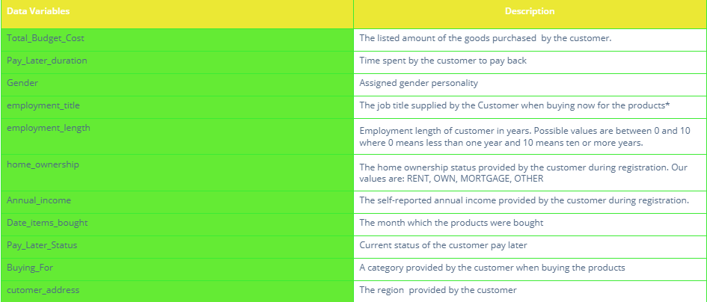

*Figure 1: The figure above illustrates the description of each variable found in the BNPL Nigerian dataset*

### 4.3.3 Data Cleaning

After the data has been prepared, the following step is to clean the data. If you want to get the most out of your data exploration, cleaning it up beforehand is the best method to do so. At this point in the process, the data has already been extracted from its primary source and prepared; the next step is to perform an analysis on it. At this level, it is harder to identify and correct errors once they have been made. In order to remedy these problems and render the data suitable for analysis, the data will first require cleaning and then will need to be formatted. Because our dataset contained no missing values, we were required to conduct a thorough examination of the data types. As a result of performing a cross-check on all of the variables, we are able to determine what values are stored in each variable and whether or not the data type that has been assigned to that variable corresponds to the values that are stored in it. Because each variable in our dataset contained categorical data, we classified them as character variables rather than factor variables. These variables included "Gender," "Environment Length," "Home Ownership," and "Pay Later Status." It was necessary to do cleaning on these variables in order to change them from being of the character type to being of the factor type, which is the correct type of data.

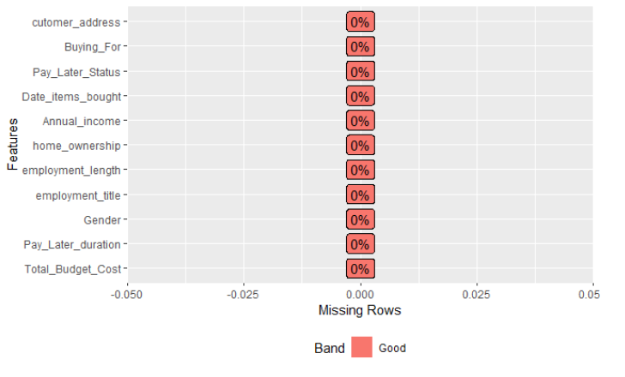

# Figure 2: Above is a figure showing cleaned dataset with no missing values

### 4.3.4 Data Statistics

After cleaning and tidying our data we went on to have a look at the overall dataset statistics. We start by displaying the structure of our dataset. Thereafter, we find the statistics in our dataset using the “describe()” method. This method is found in the “Hmisc” R package. Therefore, we start by loading the “Hmisc” package in order to be able to use the describe function. The results are then found/generated by this function. It is significant to perform descriptive statistics on our dataset. This is because descriptive statistics enables us to present the data in a more meaningful way, which allows simpler interpretation of the data. In the context of statistical analysis, the term "descriptive statistics" refers to a certain style of analysis that contributes to the effective communication of the significance of the data in a manner that is both clear and succinct. For instance, patterns might start to form. On the other hand, descriptive statistics don't let us draw any conclusions about the data we've looked at or about any assumptions we could have had. This is because descriptive statistics don't provide enough information. There is no problem with them that is rooted in their nature.

If we presented the data without the assistance of descriptive statistics, it would be quite difficult to comprehend what the data are trying to communicate. This is especially important to keep in mind when there is a substantial amount of data. Using descriptive statistics, the data can be presented in a manner that is easier to comprehend, which ultimately makes data interpretation much simpler. Utilizing descriptive statistics will allow us to have a better understanding of how our data variables are distributed.

# CHAPTER FIVE: RESULTS AND FINDINGS

The purpose of this part was to investigate unpaid external data sources (the internet), which may be put to use for the purpose of developing a deeper comprehension of a company model's customer base. More information from a wide variety of sources has been compiled in order to achieve a more in-depth comprehension of the characteristics of the purchase now pay later business model while interacting with customers. Credibility, reliability, relevance, and accessibility were the four factors taken into consideration during the evaluation of the additional data sources (data format). The dataset was made possible by the contribution of a wide array of components. This buy now pay later dataset is being collected for a number of different purposes, the most important of which are research aims, research problems, and research hypotheses. Because I already had the knowledge I required, figuring out which model would be most appropriate for addressing our problem statement was made much less difficult for me.

## 5.1 Research Objective 1

The analysis of the influence of the buy now pay later business strategy on the level of customer satisfaction as well as the success of the company was the primary focus. The "total budget cost" of the clients is taken into consideration here as one of the variables. This occurs when the customers collect their buy now goods from the business store. The "Annual income" of each customer is the second variable that is taken into consideration. In addition, once a customer has made a purchase in the shop, they are given the option to pay for it at a later date. The variables that have been discussed above have a significant impact on the level to which one can determine the impact that a purchase now pay later business plan has on the level of customer happiness, as well as the overall performance of the business. According to the findings that were discovered by applying our dataset, a large number of customers have a history of making payments precisely as intended, in contrast to the smaller number of customers who have not completed their payments precisely as intended. The frequency of the late payment status is represented by the figure below, which offers a clear indication of the number of customers who have paid for the things they purchased and the number of customers who have not yet made their payments.

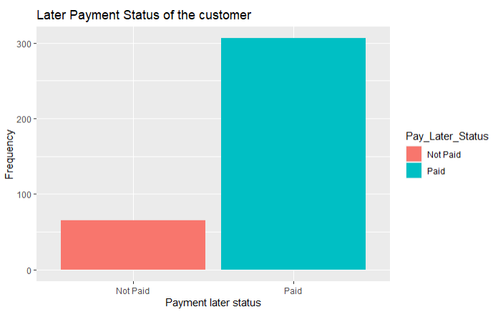

### Figure 3: Above shows frequency of Later Payment Status of the customer

In a similar manner, we moved on and performed analysis using the variables "Annual income" and "total budget cost." The fact that yearly income and total budget cost have been discovered to have a correlation suggests that the customer's annual income has an effect on the total budget cost that the consumer incurs when shopping at the buy now pay later business. The graph gives the impression that the majority of clients do not spend more than twenty thousand dollars as their total cost budget while making purchases of goods from a store that offers "buy now, pay later" payment plans. In addition, the vast majority of customers who engage in the tactic of "buy now, pay later" have an annual income of approximately fifty thousand dollars (50,000), whereas only a minority of customers have a greater annual income of more than fifty thousand dollars (50,000). When compared to the number of male clients, the number of female customers is slightly higher. The following chart compares the total annual income of each consumer to the total budget cost that was spent on purchasing the goods.

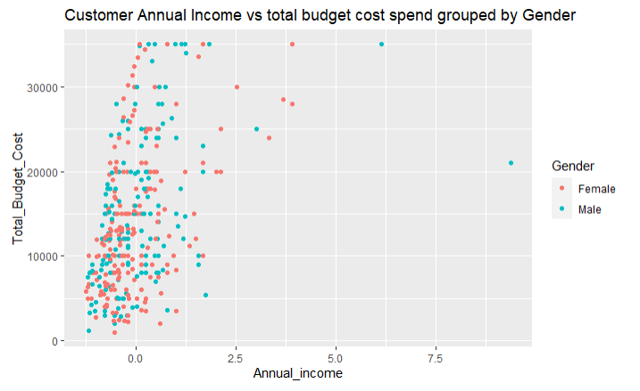

Figure 4: Above illustrates the customer Annual Income vs total budget cost spend by the customer grouped by Gender.

## 5.2 Research Objective 2

The purpose of this objective was to examine how the implementation of data analytics in purchase now pay later models will influence the success of businesses in Nigeria. This objective takes into consideration all of the dataset variables as well as how well they have done in our dataset. In our example, we conducted a number of analyses on a wide variety of variables in order to determine how well they performed in relation to the whole dataset. It was necessary to employ variables such as the combination of the "Buying For" variable and the "Gender" variables. The management of the company is able to determine which categories of products are preferred by which genders by carefully examining the graph that has been supplied to them. In comparison to male consumers, the female gender of the buy now pay later business's clients has a higher rate of satisfaction with all of the company's products and services, as shown by the graph. However, management is also able to determine which of the products now available for purchase performs better than the others. The values from our "Buying For" variable are depicted in the following picture, which compares them to "Gender" variables of various types.

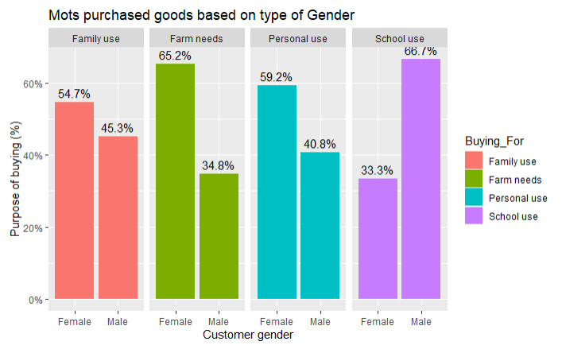

Figure 5: Above shows the “Buying_For” vs “Gender” type of customers.

## 5.3 Research Objective 3

The purpose of this objective was to assess the manner in which buy now pay later companies in Nigeria make use of data analytics to shape their customers' attitudes and behaviors regarding knowledge management. In the field of data analytics, the practice of studying raw data in order to extract conclusions from it is known as "data mining." Data analytics can be thought of as both a field of study and a set of applicable abilities. In order to carry out data analytics, there must first be raw data consisting of relevant variables that are connected to one another and that contain a wealth of information. When an analysis is done on a business organization, having this kind of rich information that is related will lead to results that are relevant to the company organization. Because of this, it is clear that the company has a responsibility to make certain that the data records they collect contain all of the information that is pertinent and that can be required for carrying out data analytics in order to derive patterns that can assist in making the company more successful. Having said all of this, it is abundantly evident that it is the responsibility of the company to guarantee that well-planned and well-executed management procedures are utilized in the general business operations in order to accomplish all of this. When we look at the dataset for the Buy Now Pay Later business, we can see quite clearly some of the procedures that the company has put into place in order to improve data analytics. Variables that are good indicators of variables that play a significant role in the company data include things like the "employment title" of a particular client, the "annual income" of a customer, the "employment length" of each and every customer, and so on. There are obvious signs on how these variables considerably effect the primary goal of this business model (which is to earn enormous cost/revenue from the items sold) when analytics are done on these variables. The main objective of this business model is to make huge profit from the sale of goods. As a result of employing the graphs and plots generated from the company information by using data analytics, our method of management of the business has changed as a business organization. The graphs that were produced as a consequence of data analytics can be simply used by management in order to change the management techniques that they now use.

In case one, using the below diagram, one can tell the best performing goods form the one sold to the customers. Therefore, as a management, new strategies are set to improve on the same product as well as finding an alternative on how to improve the least performing goods.

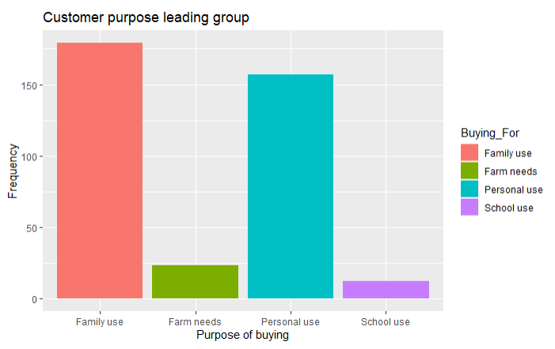

### Figure 6: .The customer purpose goods leading group

In the second case, using the below diagram, one can tell the top goods that generate high revenue/income to the buy now pay later business after they have been sold to the customers. Therefore, as a management, new strategies are set also to improve on the same product as well as finding an alternative on how to improve the least goods that make less returns into the business.

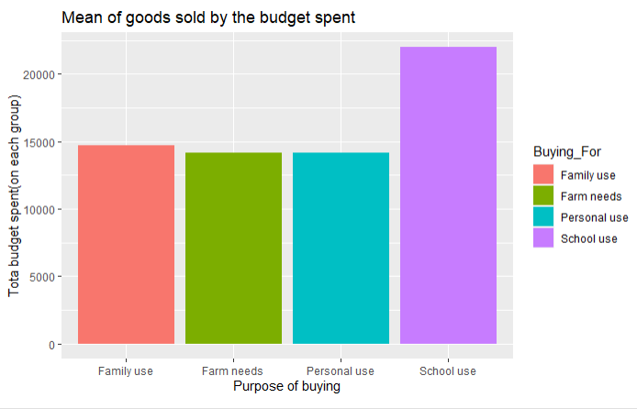

### Figure 7: The above graph shows the Mean of goods sold to the customers against the budget spent on each group of goods.

# CHAPTER SIX: DISCUSSION

This section provides a clear discussion on the results outlined in the previous chapter in detailed. From the discussion made, suggestions and recommendations as well are provided in order to help the Buy Now Pay Later business organization make much informed business decisions. This overall paper provides us with three research objectives which we are aiming at. These research objectives complement the research hypothesis which we are also testing in order to accept or reject them.

## 6.1 Research Objective 1

The first research objective states that we have to analyze the impact of the buy now pay later business strategy on customer satisfaction and business performance. Specific dataset variables were considered in order to attain this objective. With the specific variables in use results were found. According to the results generated, It is evident that many customers who get services from the business organization of buy now pay later were very satisfied. What proves this is the ability of over 90% to customers to pay for the goods they bought later and remaining with only few customers who have not managed to pay back. Also, this is a good indicator of a developed trust between the customers and the business organization with its goods and services offered. The thing here is that, customers have liked the business model of buy now pay later. Its is evident that this business strategy can bring in more customers on board thus the business ends up making revenue out of it in the later payment days.

Further, by following the revenue generated as a result of payments made from the customers, its evident that almost all customers spend more. Goods taken by customers sums up to high budget cost. This means that, customers when using the buy now pay later strategy, find its easy to collect as many goods as possible which in turn sums up to a good amount for each customer.

To conclude on this objective, its clear that, by looking at how each and every customer responds back to the business through the way they make their payments later and the total amount of money they spend in this business as per individual shows that customers are well satisfied with this kind of business model.

## 6.2 Research Objective 2

According to the second research aim, one of our responsibilities is to analyze how the implementation of data analytics in buy now pay later affects the overall performance of businesses in Nigeria. After getting the dataset for buy now pay later in the right location, we carried out the analysis on it. We are able to form opinions based on the representations of plots and graphs, which are the same as those illustrated in the chapter before this one (chapter 4). The findings unequivocally demonstrate that the availability of data analytics makes the buy now, pay later business model an excellent choice. This is due to the fact that the purchase now pay later management, by making use of the graphs that are produced as a consequence of performing analytics on the dataset of their firm, are able to easily come to conclusions and make decisions that are well informed. To provide a bit more context, the visualizations that have been supplied highlight the essential information that is desperately need. With this knowledge, it is possible to determine whether the buy now pay later business model is reasonable in light of the expectations. In our particular instance, one of the several visualizations that were created showed that the girl was the better performer when compared to the guy (the most buying gender as well as the most paying gender). The management is now in a position to determine which gender is more successful in the buy now pay later business as a result of considering this information. As a result of this information, they are in a better position to formulate a strategy to bring in more alluring products that cater to the preferences of the gender that they have determined makes the most purchases. This is particularly useful in the business of "buy now, pay later," which creates a significant quantity of client and sales data on a daily basis. Without the assistance of data analytics in place, the management absolutely cannot be in a position to be able to make all of these adjustments. Therefore, in order for the purchase now pay later business to ensure the smooth operation of their own company, it is necessary for them to collect more pertinent data and incorporate data analytics.

## 6.3 Research Objective 3

According to the third and final research objective, we are required to conduct an analysis of the ways in which data analytics are applied in Nigerian buy now, pay later businesses in order to determine their impact on knowledge management practices. It should be obvious that data analytics refers to both the science and the abilities that are required to evaluate raw data in order to draw conclusions about the information. This indicates that data analytics can only be performed in environments where there is a presence of data, and not just any data but data that is relevant to the business in order to generate accurate results that the management of the business can use to improve the operation of the business smoothly. With this in mind, it is the responsibility of the businesses that offer buy now, pay later options to compile the necessary dataset whenever transactions take place so that it can be used in the step that involves data analytics. After then, data analytics will be performed on the information that was gathered from the firms that provide buy now, pay later options. As a consequence of this, crystal-clear visualizations with accurate labels will be produced. The management is responsible for going over these outcomes, which were obtained as a result of carrying out data analyses. Because the information is presented in a visual format, it is much simpler to comprehend what is going on in the company in general. For instance, in our case, a great deal of graphic content has been produced. One of them was a graphic representation of the group of products that were purchased the most frequently by our clients. The products that fell under the family category were the ones that were purchased the most. On the other hand, there was not a significant difference between it and the other items. When an organization has access to the kind of information described above, it is simple to generate opinions. As a result, we as a team are kept abreast of the most recent developments. As a result, we create fresh understanding regarding the management of the firm.

## 6.4 Limitations

In spite of the fact that I was able to successfully analyze my dataset for the Nigerian company BSPL, I was limited in a number of other respects. For this reason, the study could only make use of historical data provided by Nigeria's BSPL business company. I'm basing what I'm doing on the historical records of the Nigerian company BSPL, which is in the business of oil and gas. Even though this is not a negative development, the execution of this data analysis project could have been enhanced if we had used data that was collected in real time. In order to conduct data analysis, we make use of a particular kind of data that is continuously produced by the BSPL business company in Nigeria.

## 6.5 Conclusion

In conclusion, buy now and pay later businesses generates large volume of dataset each day whenever transactions take place with its customers. As a result, there is need to make this large volume of dataset useful and effective back to the business itself. Thus, here comes in data analytics, a mechanism that helps in finding patterns out of the raw data in order to help the business make informed decisions. This means that data analytics and the buy now and pay later businesses depend on each other. If data is generated without data analytics, it becomes useless to the business. Therefore, it’s evident that, there exist a positive relationship between data analysis and the buy now and pay later businesses. Thus, we accept the null hypothesis.

Further, data analytics provides clear and informed visualizations to as a result from the raw data back to the management. The management of the business are now in a position to go through the visualizations produced and by doing this, new patterns are realized form the results generated. These patterns play a vital role by inserting new knowledge in the management team which later come up with new and different strategies in order to improve and make necessary adjustments so that revenue goes high. With this kind of information, its evident to say that there is a positive correlation between data analytics and the knowledge management practices.

Finally, knowledge plays a vital role in the whole process of managing the buy now pay later business. As we have seen form the visualizations displayed in the results section, we get knowledge by looking at them. With the knowledge that we get, we become creative by coming up with new strategies on how to make our business effective and more profitable than before. Knowledge helps the management team to realize faults, weakness and strengths in the business operation, thus vital. With the knowledge found, we can know how to prevent/mitigate the faults, strength the weakness found and maintain and improve the strength realized. Therefore, there exists a positive relationship between the knowledge management practices and the performance of the buy now pay later businesses in Nigeria.

## 6.6 Recommendations

I do recommend that, buy now pay later business can thrive best whenever data analytics mechanism is applied in the business operation. Therefore, business operating under buy now pay later business model should consider integrating data analytics in the business in order to increase the business income whenever later payment comes from the customers. Knowledge plays a vital role in enhancing the effectiveness of the business. The fact that data analytics is the best place to generate knowledge required, thus indicates that the business still should consider data analytics again and again as the source of thriving their business. Therefore, data analytics is the way to go. I also recommend that, buy now pay later business should consider collecting data using the relevant variables. Variables that have no relation when used during data collection will generate raw data that cannot derive accurate patterns to thrive this business since it is the relation of these variables that leads generate the patterns that is needed in the business operation

# REFERENCES

Ain, N., Vaia, G., DeLone, W. H., & Waheed, M. (2019). Two decades of research on business intelligence system adoption, utilization and success–A systematic literature review. *Decision Support Systems*, *125*, 113113.

Alqatan, A., Chbib, I., & Hussainey, K. (2021). Theories related to the relationship between board diversity, earnings management, and firm performance. *Corporate governance and its implications on accounting and finance*, 1-26.

Bag, S., Wood, L. C., Xu, L., Dhamija, P., & Kayikci, Y. (2020). Big data analytics as an operational excellence approach to enhance sustainable supply chain performance. *Resources, Conservation and Recycling*, *153*, 104559.

Bhuyan, A. H. M. M. I. Organizational Performance Management and Leadership Development: Theories, Styles, Ethical, and Legal Issues. In *MESSAGE FROM THE CONFERENCE CHAIRS* (p. 356).

Dahlgaard-Park, S. M., Reyes, L., & Chen, C. K. (2018). The evolution and convergence of total quality management and management theories. *Total Quality Management & Business Excellence*, *29*(9-10), 1108-1128.

Daradkeh, M. K. (2018). Determinants of visual analytics adoption in organizations: Knowledge discovery through content analysis of online evaluation reviews. *Information Technology & People*.

Diaz-Kope, L. M., Miller-Stevens, K., & Henley, T. J. (2019). An examination of dissertation research: The relationship between gender, methodological approach, and research design. *Journal of Public Affairs Education*, *25*(1), 93-114.

Dubey, R., Gunasekaran, A., Childe, S. J., Blome, C., & Papadopoulos, T. (2019). Big data and predictive analytics and manufacturing performance: integrating institutional theory, resource‐based view and big data culture. *British Journal of Management*, *30*(2), 341-361.

Fernandes, G., dos Santos Mendes, L., & de Oliveira Leite, R. (2021). Cash holdings and profitability of banks in developed and emerging markets. *International Review of Economics & Finance, 71*, 880-895.

Ghasemaghaei, M. (2019). Does data analytics use improve firm decision making quality? The role of knowledge sharing and data analytics competency. *Decision Support Systems*, *120*, 14-24.

Goodman, P., Robert, R. C., & Johnson, J. E. (2020, November). Rigor in PhD dissertation research. In *Nursing forum* (Vol. 55, No. 4, pp. 611-620).

Grover, V., Chiang, R. H., Liang, T. P., & Zhang, D. (2018). Creating strategic business value from big data analytics: A research framework. *Journal of Management Information Systems*, *35*(2), 388-423.

Hadi, M. S., Lawey, A. Q., El-Gorashi, T. E., & Elmirghani, J. M. (2018). Big data analytics for wireless and wired network design: A survey. *Computer Networks*, *132*, 180-199.

Hallikainen, H., Savimäki, E., & Laukkanen, T. (2020). Fostering B2B sales with customer big data analytics. *Industrial Marketing Management*, *86*, 90-98.

Harwood, N., & Petrić, B. (2019). Helping international master’s students navigate dissertation supervision: Research-informed discussion and awareness-raising activities. *Journal of International Students*, *9*(1), 150-171.

Janesick, V. J. (2021). Reflection on Why We Need Methodologists on Dissertation Committees. *Research in the Schools*, *27*(1).

Kadam, A., & Joshi, S. (2019). Introduction to design dissertation & research methodology.

Kamble, S. S., & Gunasekaran, A. (2020). Big data-driven supply chain performance measurement system: a review and framework for implementation. *International Journal of Production Research*, *58*(1), 65-86.

Khanra, S., Dhir, A., & Mäntymäki, M. (2020). Big data analytics and enterprises: a bibliometric synthesis of the literature. *Enterprise Information Systems*, *14*(6), 737-768.

Khanra, S., Dhir, A., & Mäntymäki, M. (2020). Big data analytics and enterprises: a bibliometric synthesis of the literature. *Enterprise Information Systems*, *14*(6), 737-768.

Komarova, A., Tsvetkova, L., Kozlovskaya, S., & Pronkin, N. (2019). Organisational educational systems and intelligence business systems in entrepreneurship education. *Journal of Entrepreneurship Education*, *22*(5), 1-15.

Kostere, S., & Kostere, K. (2021). *The generic qualitative approach to a dissertation in the social sciences: A step by step guide*. Routledge.

Lim, J., Lim, K., Heinrichs, J., Al-Aali, K., Aamir, A., & Qureshi, M. (2018). The role of hospital service quality in developing the satisfaction of the patients and hospital performance. *Management Science Letters*, *8*(12), 1353-1362.

Maylor, H., Meredith, J. R., Söderlund, J., & Browning, T. (2018). Old theories, new contexts: extending operations management theories to projects. *International Journal of Operations & Production Management*.

Mehta, N., & Pandit, A. (2018). Concurrence of big data analytics and healthcare: A systematic review. *International journal of medical informatics*, *114*, 57-65.

Monteiro, A., Cepêda, C., & Silva, A. (2021). Linking decision and utility theories to financial information usefulness and company performance: A study applied to Portuguese's certified accountants. *Accounting*, *7*(6), 1395-1406.

Opoko, A. P., Oluwatayo, A. A., Amole, B., & Adeyemi, E. (2020). How different actors shape the real estate market for informal settlements in Lagos. *Environment and Urbanization, 32*(2), 371-388.

Petrillo, A., De Felice, F., & Zomparelli, F. (2019). Performance measurement for world-class manufacturing: a model for the Italian automotive industry. *Total Quality Management & Business Excellence*, *30*(7-8), 908-935.

Popovič, A., Hackney, R., Tassabehji, R., & Castelli, M. (2018). The impact of big data analytics on firms’ high value business performance. *Information Systems Frontiers*, *20*(2), 209-222.

Queiroz, M. M., & Telles, R. (2018). Big data analytics in supply chain and logistics: an empirical approach. *The International Journal of Logistics Management*.

Raut, R. D., Mangla, S. K., Narwane, V. S., Gardas, B. B., Priyadarshinee, P., & Narkhede, B. E. (2019). Linking big data analytics and operational sustainability practices for sustainable business management. *Journal of cleaner production*, *224*, 10-24.

Ritter, T., & Pedersen, C. L. (2020). Digitization capability and the digitalization of business models in business-to-business firms: Past, present, and future. *Industrial Marketing Management*, *86*, 180-190.

Singh, S. K., & El-Kassar, A. N. (2019). Role of big data analytics in developing sustainable capabilities. *Journal of cleaner production*, *213*, 1264-1273.

Tseng, M. L., Wu, K. J., Lim, M. K., & Wong, W. P. (2019). Data-driven sustainable supply chain management performance: A hierarchical structure assessment under uncertainties. *Journal of Cleaner Production*, *227*, 760-771.

Ukko, J., Nasiri, M., Saunila, M., & Rantala, T. (2019). Sustainability strategy as a moderator in the relationship between digital business strategy and financial performance. *Journal of Cleaner Production*, *236*, 117626.

Upadhyay, P., & Kumar, A. (2020). The intermediating role of organizational culture and internal analytical knowledge between the capability of big data analytics and a firm’s performance. *International Journal of Information Management*, *52*, 102100.

Vassakis, K., Petrakis, E., & Kopanakis, I. (2018). Big data analytics: applications, prospects and challenges. In *Mobile big data* (pp. 3-20). Springer, Cham.

Zaim, H., Muhammed, S., & Tarim, M. (2019). Relationship between knowledge management processes and performance: Critical role of knowledge utilization in organizations. *Knowledge Management Research & Practice*, *17*(1), 24-38.

Zhou, S., Qiao, Z., Du, Q., Wang, G. A., Fan, W., & Yan, X. (2018). Measuring customer agility from online reviews using big data text analytics. *Journal of Management Information Systems*, *35*(2), 510-539.